3. TECHNICAL RISK ASSESSMENT: PUBLIC FACING SERVICES
3.1 EXTERNAL PORT SCANNING OVERVIEW
3.1.1 Public IP ranges and scoped targets
The initial identification of a major telecommunications operator public IP ranges was based on Autonomous System (ASN) look up tools of the telecommunications operator and more specifically, the [ASN anonymized] and associated telecommunications operator ASNs. These ASN pages include the IPv4 prefixes currently announced by the telecommunications operator to the internet, for example ****/16 and some other netblocks owned by them. Only prefixes that were expressly assigned to the telecommunications operator were in scope meaning that third party or CDN addresses (such as ****) that were returned by DNS were not in scope even when used to serve their web pages. Because a /16 has 65,536 IP addresses and they have more than one netblock, thus it would not be required to scan all the IP addresses, which would be slow and noisy, but instead a sampling mechanism was applied. Some /24 subranges were chosen within their prefixes (e.g. ****/24, ****/24, ****/24 and ****/24) and small number of IPs within each /24 were probed. This permitted evaluation of various components of the public perimeter of the telecommunications operator (several netblocks) without increasing the overall scan volume and within the permission of the telecommunications operator public IPs.
Since it would have been prohibitive to scan the whole /16, a few /24s in it have been sampled: ****/24, ****/24, ****/24 and ****/ 24 were chosen as a representative slice of the /16. A combination of /24s at various offsets (both near the beginning and later within the /16) prevents the assessment of only one part of the address space; large ISP blocks may contain varying size customer segments or services in varying /24s.
[ASN anonymized] ASN look up also indicates another IPv4 prefix registered to the telecommunications operator and named ***** as ****/22. This /22 is a significantly smaller (1,024 addresses) and is commonly used to support infrastructure, business services or edge nodes as opposed to mass mobile subscribers. Scanning such an IP as **** subnet was thus warranted to confirm that the perimeter behaviour observed in ****/16 is also visible in the smaller type of infrastructure block at the telecommunications operator and to make sure that the report does not depend on one /16 only, but several prefixes of the operator at [ASN anonymized].

[ASN anonymized] also announces the block ****/19 (8,192 addresses) as part of the telecommunications operator , which is the mobile ISP and hosting services of the telecommunications operator. Since this /19 denotes a wide usage in public facing as well as mobile connectivity, its inclusion provides coverage of a different type of their address space.
Scanning an address like **** with the same Nmap commands would show whether different services on hosts reachable in the block of mobile/public connectivity at the operator expose different services compared to the ** and ** ranges.
- ****/16 - huge broadband/customer assignment.
- ****/22 - smaller infrastructure/business prefix
- ****/19 - mobile ISP / public internet connectivity range.
3.1.2 Port scanning commands used
To scan the IPs that were selected, the primary TCP scan was:
sudo nmap -sS -sV -Pn –top-ports 20 <target ip> [ASN anonymized] 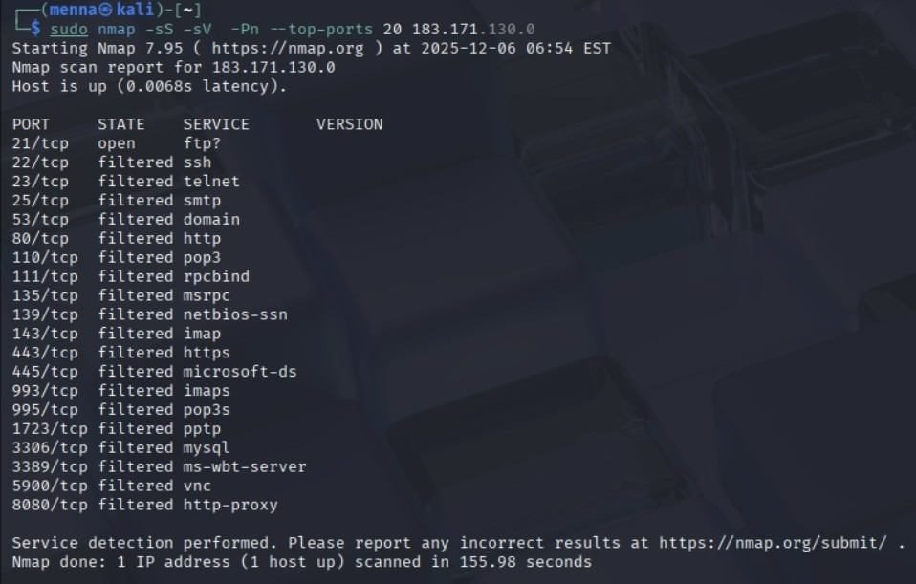
d [ASN anonymized]

- sudo was needed in order to enable Nmap to make raw packets to send SYN scans.
- -sS is a TCP SYN scan which sends SYN packets and reads SYN ACK/RST responses without sending complete TCP scans for efficiency and is typically used for external security scanning.
- -sV allows the detection of service/version which allows Nmap to connect to open ports and detect the application and version of the server (e.g. FTP server banner) required by vulnerability mapping and MITRE ATT&CK mapping.
- -Pn prevents host discovery and considers it alive, which is useful to prevent losing targets when probes are filtered by firewalls.
- -- top-ports 20 limits the scan to the 20 most commonly used TCP ports, reducing the scan time and traffic while still covering the most frequently exposed services to the internet.

For one representative host of each pattern, a more thorough TCP scan was executed:
sudo nmap -sS -sV -Pn -p 1-1000 <target ip>
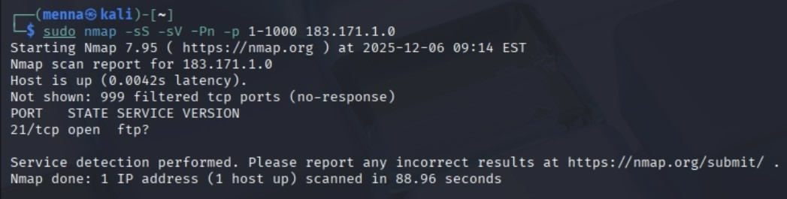
This is an extension of the scan of top 20 to the first 1000 TCP ports in order to ensure the absence of any other ports that were open; identical flags were maintained such that outcomes were comparable (SYN scan, version detection, no ping).
A focused UDP scan was performed to investigate the UDP exposure on same IPs:
sudo nmap -sU -p 53,67,68,123,161 <target ip>
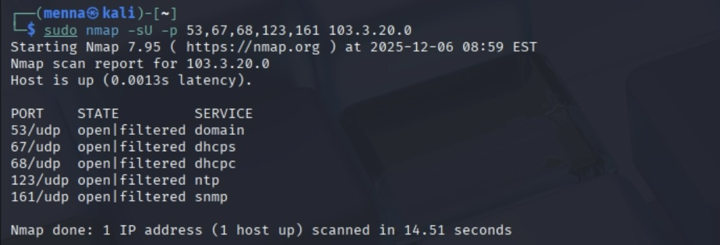
- -sU enables UDP scanning.
- Common UDP services were selected (53 (DNS), 67/68 (DHCP), 123 (NTP) and 161 (SNMP)) which are relevant to infrastructure but frequently abused by attackers
Very fast TCP confirmation scan was occasionally employed:
nmap -T4 -F <target ip>
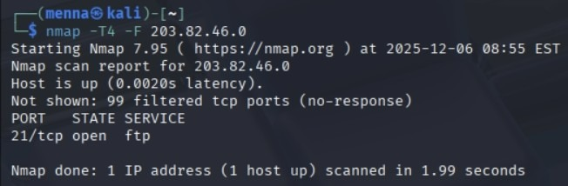
- -F is very fast and only scans the most common 100 ports
- -T4 speeds up timing and gives a fast cross check that only the open ports from the regular scan (the results) are open.

3.2 IDENTIFIED PORTS AND SERVICES
3.2.1 TCP scan results
On several telecommunications operators IPs of varying netblocks, the top-ports TCP scans always gave the same output:
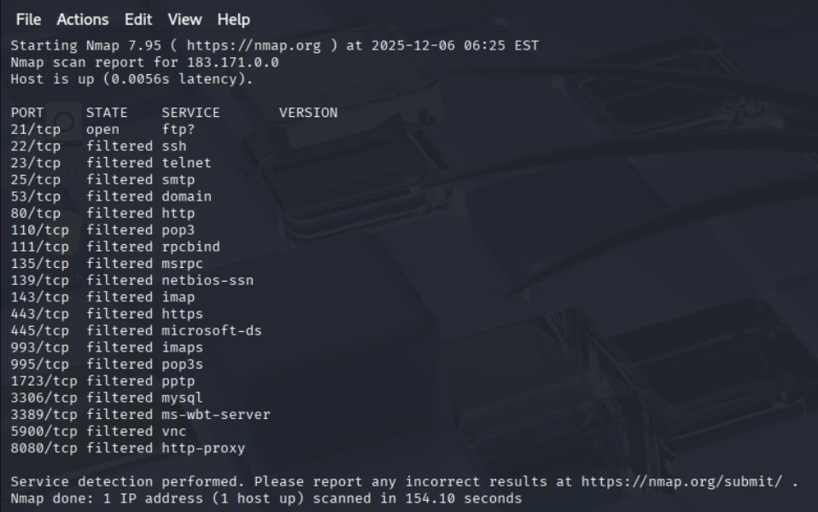
Fig 1. nmap regular scan results for ****

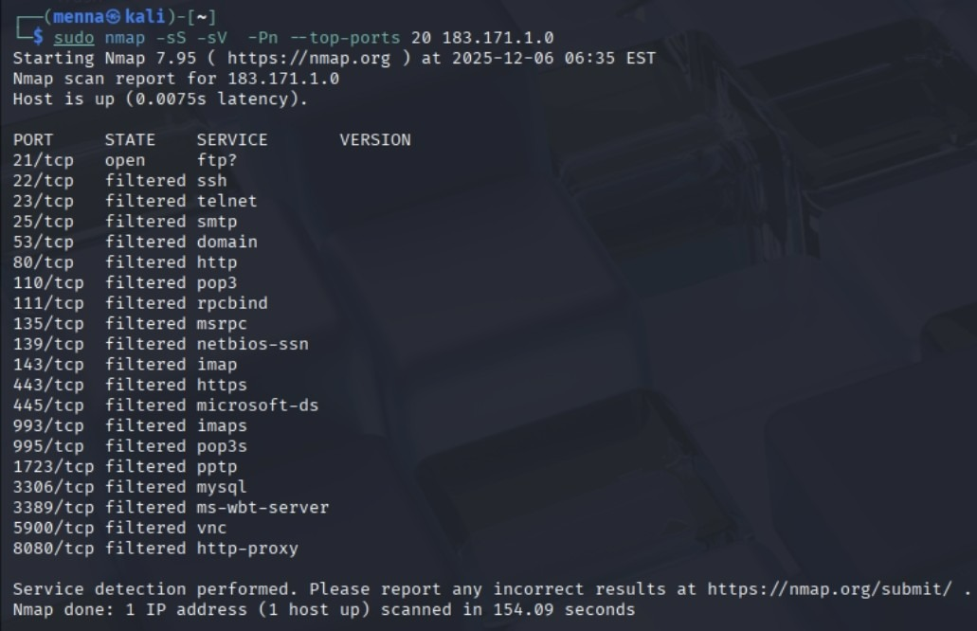
Fig 2. nmap regular scan results for ****

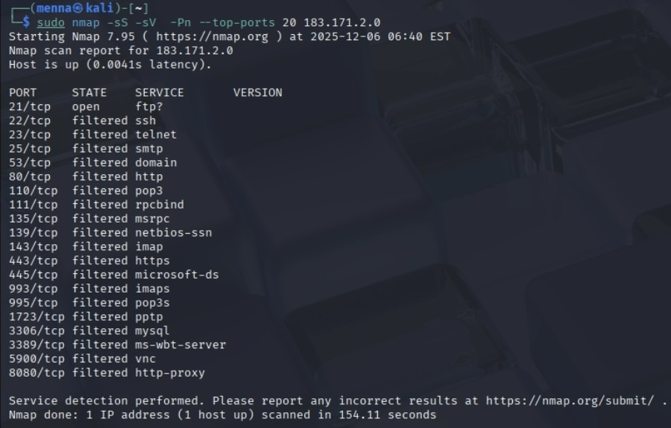
Fig 3. nmap regular scan results for ****
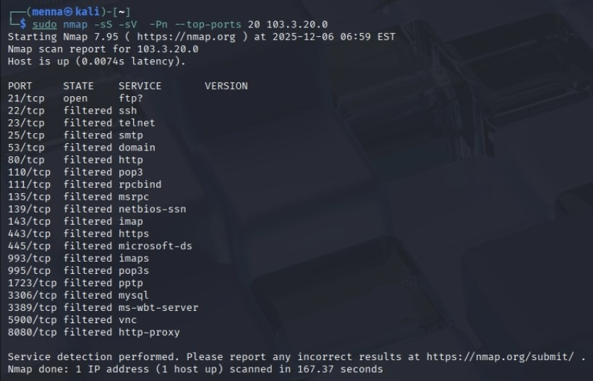
Fig 4. nmap regular scan results for ****
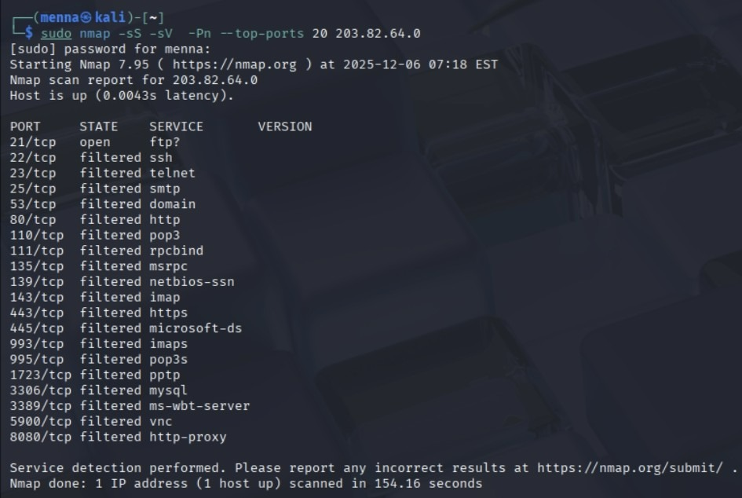
Fig 5. nmap regular scan results for ****

As shown in the screenshots above:
- 21/tcp - open. Service identified as FTP (banner ftp? in the Nmap output means that an FTP server is responding on the default FTP control port).
- Any other scanned TCP ports (22, 23, 25, 80, 110, 143, 443, 3389, 5900, 8080 etc.) - filtered - where such services as SSH, HTTP, HTTPS and RDP are identified as filtered.
The further scan of one host with the option -p 1-1000 proved that all the 21/tcp ports were open and the rest 999 were filtered (Not shown: 999 filtered tcp ports):

Fig 6. A deeper scan on ****
In nmap, open means the port responds positively; meaning that there is an application actively running on that port. filtered means nmap is unable to tell whether the port is open or not, as no reply is received or only ICMP messages are received; this is likely to mean that the port is blocked by a firewall or packet filter.
The FTP open, other filters pattern repeated over IPs and netblocks is indicative of a planned perimeter setup: FTP is open to the internet on some gateway hosts, and the rest of the common TCP-based services are blocked by the firewalls.
3.2.2 UDP scan results
Ports included in the state open|filtered in the UDP scans on the same IPs were 53/udp (domain), 67/udp and 68/udp (DHCP), 123/udp (NTP) and 161/udp (SNMP).

Fig 7. udp scan results for ****
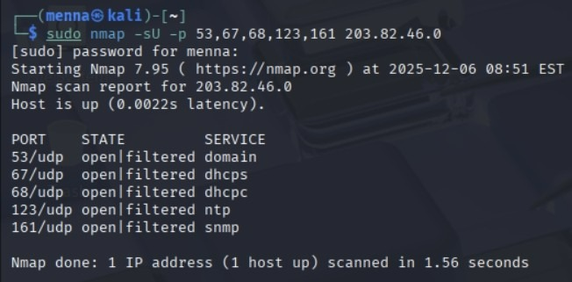
Fig 8. udp scan results for ****
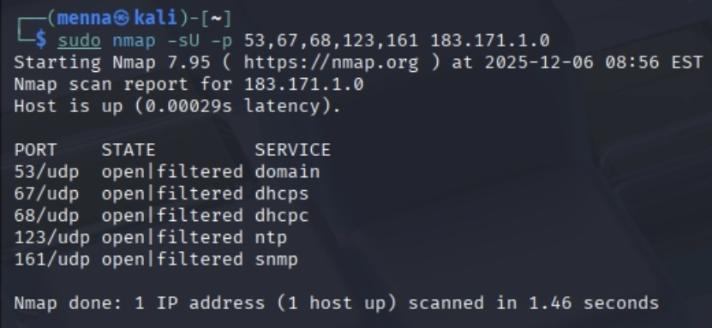
Fig 9. udp scan results for ****
In the case of UDP, the meaning of open|filtered means that nmap is not getting a response or an ICMP "port unreachable" error, hence it is unable to differentiate between an open UDP service that ignores unexpected packets and a firewall that blocks traffic. These are ports that may be potentially open but cannot be confirmed as open from an external viewpoint; they represent potential infrastructure services (DNS/NTP/SNMP) beyond filtering

